 | Mao Zedong | Deng Xiaoping | Jiang Zemin | Hu Jintao | Xi Jinping
 | 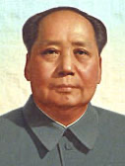 | 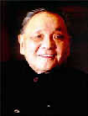 | 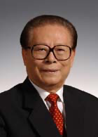 | 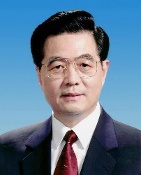 | 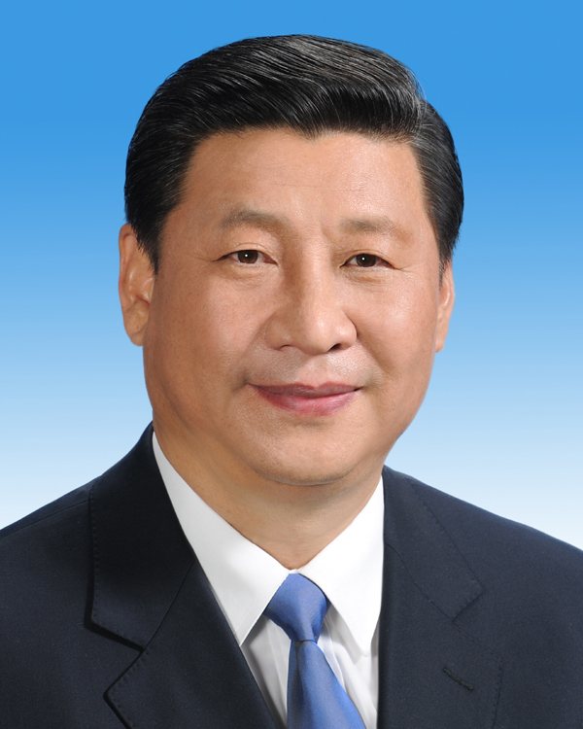
In power | 1949-1976 | 1978-1989 | 1989-2002 | 2002-2012 | 2012-present
Born in | 1893 | 1904 | 1926 | 1942 | 1953
Still alive? | Died in 1976 | Died in 1997 | Died in 2022
Joined the Party in (or started working for the Party) | 1921 | 1922 | 1943 | 1965 | 1969
Birthplace | Hunan | Sichuan | Jiangsu | Anhui | Shannxi
Education | Traditional education | Study and work abroad | Shanghai Jiaotong | Tsinghua | Tsinghua
Highest Title(s) | Chairman of  CPC and PRC | Chairman of  CPC and PRC  Military Commission | President of PRC  General Secretary of CPC  Chairman of CPC and PRC Military Commission
Premiers | Zhou Enlai | Zhao Ziyang  Li Peng | Li Peng  Zhu Rongji | Wen Jiaobao | Li Keqiang  Li Qiang (2023-)
Other key  figures | Liu Shaoqi  Lin Biao  Jiang Qing  Hua Guofeng | Chen Yun  Hu Yaobang  Zhao Ziyang

